Software Requirements Specification

Version 0.1

8/5/2018

Project WhiteFox

Denis
Lim Hoe Ann
Mark Anthony Midin
Ng Soon Cheng

Submitted in partial fulfillment
Of the requirements of
SEG2202 and name

Table of Contents

Table of Contents i
List of Figures ii
1.0. Introduction 1
1.1. Purpose 1
1.2. Scope of Project 1
1.3. Glossary 2
1.4. References 2
1.5. Overview of Document 3
2.0. Overall Description 4
2.1 System Environment 4
2.2 Functional Requirements Specification 5
2.2.1 5
2.3 User Characteristics 6
2.4 Non-Functional Requirements 7
3.0. Requirements Specification 9
3.1 External Interface Requirements 9
3.2 Functional Requirements 9
3.3 Detailed Non-Functional Requirements 10
Index 11

List of Figures

Figure 1 Overview of WhiteFox System 5
Figure 2 User: Login & Register User 6
Figure 3 User: View Profile 6
Figure 4 Volunteer: Search Activity 7
Figure 5 Organization: Remove Activity, List Activity, and Accept Volunteers 7
Figure 6 Admin: Suspend User, View Messages, and Approve Activity 8

< generate here >

1.0. Introduction

1.1. Purpose
This documentation is meant to help present developers and developers in future to identify and understand the various requirements for Project WhiteFox.
< Clearly state the purpose of this document and its intended audiences. Note that this subsection does not describe the project. >

1.2. Scope of Project
This project is to create a website that serves as a platform to connect two distinct group of users and an admin user for the website. First group, the “Volunteers” are users comprised of any Malaysian citizen that seeks to provide or share their expertise in any field while adhering to Malaysia’s sovereign law. Second group, the “Organization” users are user that has company profile registered with Suruhanjaya Syarikat Malaysia. The “Organization” user represent an organization that they belong to and said organization is creating opportunities and requires aid from voluntary Malaysian citizens in their campaigns, events, activities, etc.
The admin’s role is to screen all postings and registrations of an “Organization” user while serving as technical support to both user group using the website.
< Overview the project briefly. Tell the name of the product to be created. Explain what it will do in general terms. If needed, tell what it will not do. Describe the need, context, and rationale for the system. Discuss how it fits into the overall business or strategic objectives of the organization. Describe previous versions of the software (if any) and the relationship with the proposed version. The explicit functionality of the project is described in the sections below. >

1.3. Glossary
< Define the terms, acronyms and abbreviations used in this document. Do not assume the experience or expertise of the reader. Each type of reader will have a technical vocabulary not necessarily shared by other readers. Use a table and alphabetize. >
Term | Definition
Activity | Events organized by organization it can be a recurring or a one-shot event. It can be a part time position as well for events with undetermined duration.
Organization | Registered users that represent their organization that wants to seek voluntary aid without any compulsory reimbursement in any form.
Surahanjaya Syarikat Malaysia (SSM) | A Malaysian government body that holds all information related to a company’s profile. Every non-profit and profit organization in Malaysia must be registered with them and has a unique business registration number.
Volunteers | Registered users that is a citizen of Malaysia regardless of gender, affiliation, and above 18 years old. All Malaysian citizen must have a unique identification number that they will acquire at the age of 12 and above.

1.4. References
http://www.ssm.com.my/en/e-Info-Mainpage
https://www.ssm-einfo.my/sample/samplerob.pdf
< List here any references to other documents cited anywhere in this document including references to related project documents. Add references here when other project documents are created. Give complete identifications as this is usually the only Bibliography in the document. >

1.5. Overview of Document
The following sections are divided into two parts; First part, Overall Description that serves to provide a quick idea for non-detailed discussion purposes about the capability and constraints from system requirements, functional requirements and non-functional requirements among stakeholders and developers involved in this project.
Second part, Requirements Specification are meant for current developers involved in this project and serves as references for any expansions or upgrades to the system for developers in future. The Specification Requirement holds the details of each functional requirement and non-functional requirement with its corresponding use case diagrams wherever necessary to illustrate the process, flow, objects that is involved in the website system.
< Describe the contents and organization of the rest of this document. Since there is already a Table of Contents, this overview will be less formal but more informative. Describe the two basic remaining sections, the Overall Description and the Requirements Specification. Include intended audiences of each. >

2.0. Overall Description

2.1 System Environment
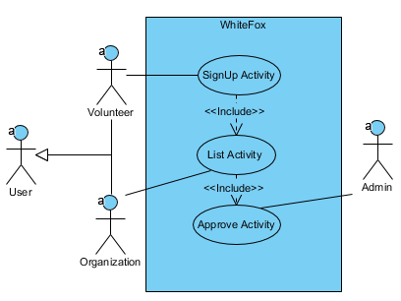
There are three actors that interacts with the system. Two of them are subclass of ‘User’ superclass, they are the primary audience of this website-based system. The third actor are Admin that serve to facilitate any non-technical and unforeseen technical issues that may arise from the User group. Unforeseen issues can arise from external environment of the system due to non-functional requirements such as changes in Malaysian’s law or any human-made error while using the system.

< This diagram and accompanying explanation describes the relationship between the system, its components and the external environment of the system. Include all actors interacting with the system. The purpose of this diagram is to clearly show what is part of your system and what is not part of your system. If it is a stand-alone single-user system, that information is noted here. >

2.2 Functional Requirements Specification
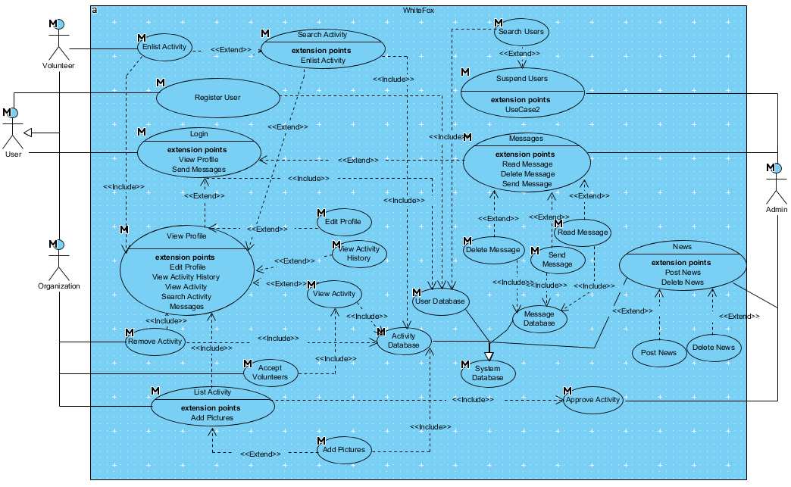
Figure 1 Overview of WhiteFox System

Figure 1 Overview of WhiteFox System shows every functional requirement and how each actor interacts with the system. The first actor is “Admin”, second actor “Volunteer”, and third actor “Organization”. There are two superclass in this system, first is “User” actor that extends to actor “Volunteer” and “Organization”. The second superclass is the “System Database” that extends to “User Database” and “Activity Database”. The following diagrams will be referenced according to their Figure Number for other sections of this document. The diagrams are broken down based on the functions each actor can perform starting from “User”, “Volunteer”, “Organization”, and finally “Admin”.

2.2.1
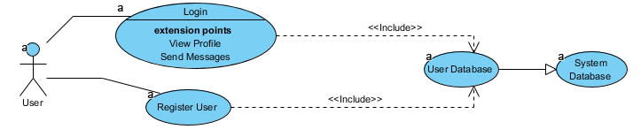
Figure 2 User: Login & Register User

Brief Description
Users can register user or login to the website.

2.2.2
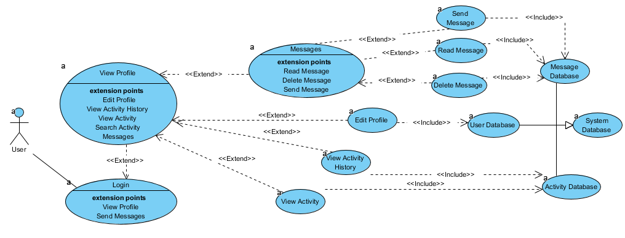
Figure 3 User: View Profile

Brief Description
Users can view profiles after they login, then send message and delete message or edit profile or view activity history or view activity

2.2.3
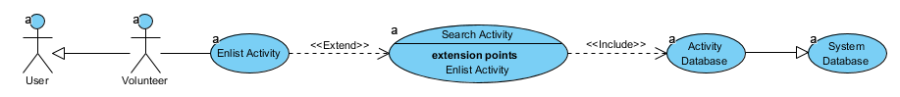
Figure 4 Volunteer: Search Activity

Brief Description
Volunteer can enlist activity once they have login and in view profile

2.2.4
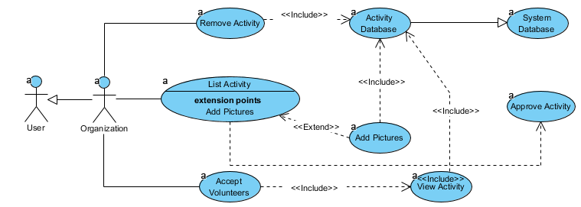
Figure 5 Organization: Remove Activity, List Activity, and Accept Volunteers

Brief Description
Organization can remove activity, list activity, and accept volunteers once they have login as user.

2.2.5
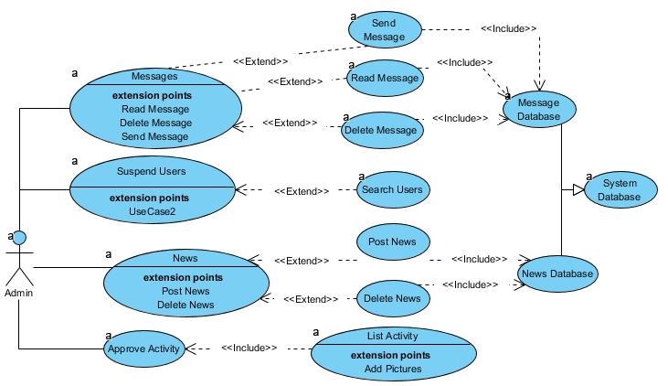
Figure 6 Admin: Suspend User, View Messages, Approve Activity, Post News, Delete News

Brief Description
Admin can suspend user, view messages, and approve activity.

< Provide an overview of the services provided to the users using simple user scenarios (brief use case descriptions). See Use Case Description document. It is important to organize this part in a manner that is easy for the user to understand. Start with a diagram (or diagrams) listing use cases by actor. Develop the brief use case descriptions by actor. Here, we only give the basic descriptions, postponing details until the next chapter. Each use case here must be explicitly cross-referenced to the following chapter (Requirements Specification) as there is no guarantee that the next section will have a similar organization.
If Domain Classes have been identified in an object-oriented approach, they may be appropriate to include in this section to facilitate the explanation given here. >

2.3 User Characteristics
- The Admin is expected to have basic knowledge of handling websites. This includes basic proficiency in SQL commands, HTML, CSS, and JavaScript to handle minor changes or updates to the websites frontpage on their own.
- The User group are expected to be English literate and digital natives. Thus, they should have minimal problem navigating the system. If any of the derived group of User faces any difficulties in using the websites; they should be able to contact the Admin to resolve their issues through “Send Message” function.
< Describe the characteristics of the intended users in terms of experience and technical expertise. At a minimum, give the characteristics of the interface for each class of users, that is, screen formats, page/window layouts, content of reports or menus. How should the system appear to the user? How detailed should error messages be? If you are using prototyping, sample interfaces may be provided but make clear what principles are required to allow consistent modifications. Sample user interfaces may be placed in an Appendix to this volume. >

2.4 Non-Functional Requirements
- The system should be hosted on a server that is accessible to everyone with internet service all the times.
- The system’s database for Organization must follow the format of SSM’s Business Information form’s Business Registration Number to crosscheck their legality if any concerns are raised.
- The Admin should ensure the legality of each organization’s identity and suspend the account should there be any complaints towards the physical organization itself. Complaints can be in the form of messages towards the Admin from User group or external sources such as local news.
- The Admin should suspend user account when it receives more than 3 complaints from any users.
- The Admin should release any users that are able to prove their innocence from any accusation that results in account suspension.
- The User should receive an e-mail notification about their successful registration within 5 min upon clicking submit.
- The Volunteer should receive an e-mail notification when they are accepted by an organization to volunteer at their activity.
- The Organization should receive any e-mail notification daily at 9 a.m. according to local time zone with a list of current volunteers that enlisted to volunteer at their activity and awaits their acceptance.

< This section includes constraints, assumptions and dependencies such as minimum memory requirements, regulatory policies, timing considerations, reliability and standards such as process or documentation standards. Assumptions and dependencies might include the expected operating system available. If there is a change then this SRS might need to be modified. Remember that all requirements must be written in a testable form. This section is for the user. A full set of non-functional requirements for the developer is contained in the Requirements Specification below. >

3.0. Requirements Specification

3.1 External Interface Requirements

3.1.1 User Interfaces
- The website must be built according to World Wide Web Consortium’s Standard.
- Uses Graphical User Interface as primary means of interacting with the website.
- Uses Window, Icon, Menu, Pointer (WIMP) for any pop-ups design.
- Doesn’t uses light flashes to accommodate users that suffer seizures from photosensitivity epilepsy.
- Minimal alarming high pitch sounds, less than 3 type of different sound per web page.

3.1.2 Hardware Interfaces
- The system does not interface towards hardware directly on the users’ end. It deals with the software interface, user interface, and communication interface only.
- The system must be hosted on a server with upload speed above 100 Mbps and 50Mbps download speed.
- It must be viewable on any user’s web browser on a desktop and laptop.

3.1.3 Software Interfaces

It should run on latest stable version of top three popular web browser and Microsoft Internet Explorer with display error below 20% due to alignment inaccuracy.

3.1.4 Communication Interfaces
- The website must be built with HTML v5.0 or latest stable version, PHP 7.0 or latest stable version.
- Uses XAMPP version 7.0.29 and above that contains all the required protocols and interfaces to host a website; this includes: -
  - Apache 2.4.33
  - XAMPP Control Panel 3.2.2
  - MariaDB 10.01.31
  - FileZilla FTP Server 0.9.41
  - phpMyAdmin 4.8.0
  - OpenSSL 1.0.2
  - Webalizer 2.23-04
  - Mercury Mail Transport System 4.63
  - Tomcat 7.0.56
  - Strawberry Perl 7.056 Portable

<List the external interface requirements, that is, list formal requirements for hardware interfaces, software interfaces, and communications interfaces. (User interfaces are covered in section 2.3 above.) These describe all of the inputs and outputs of the system including how the system works with external systems. This section is of particular interest to the people who will have to adapt the external systems to interact with this system properly. Data flow diagrams may be used effectively here. Do not duplicate information contained in other sections of this document but include specific references to that information here. >

3.2 Functional Requirements
User Use Case Description
Use Case Name | Visitor Register & Login
XRef | Figure 2 User: Login & Register User
Trigger | Visitors to the website wants to register an account
Precondition | The visitor is at any webpage without an account currently logged into the system.
Basic Path | - The Visitor clicks on the register button on webpage’s header at the top right to bring up a pop-up for registration.  - If the visitor selects “Volunteer” the pop-up will change to Volunteer’s registration. They key in their first name, last name, password, email address, telephone, NRIC.  - Then clicks submit to send the information to system’s database.  - The system sends an email to them for account validation.  - Visitor is logged into the system temporary for 1 hour as a Volunteer.  - The website header changes the login button with a logout button and displays their first name above the button.  - The Volunteer validates their account by clicking on the link provided in the email.  - The Volunteer is brought to homepage of the website.
Alternative Paths | In step 2, if the Visitor selects “Organization” the pop-up will change to Organization’s registration instead. They key in their organization’s name, password, addresses, telephone, business registration number.  - Then clicks submit to send the information to system’s database.  - The Visitor is brought back to the homepage as Visitor upon successful submission.  - The system sends an email to them for account validation.  - The Volunteer validates their account by clicking on the link provided in the email.  - The Volunteer is brought to homepage of the website logged in as their organization.
Postcondition | The Visitor has successfully register an account of their choice and logged into the system.
Exception Paths | The Visitor may abandon the registration process at any time.
Other | Null

Use Case Name | Edit Profile, View Message, Send Messages, Delete Messages, View Activity, View Activity History.
XRef | Figure 3 User: View Profile
Trigger | User wants to send messages or edit profile or view activity history or view activity.
Precondition | The user has logged into their respective account as volunteer or organization.
Basic Path | - The User clicks on their Account Name on the header to bring them to their account profile.  - If the User clicks Edit Profile  - The webpage pops-up and a window that contains all their registered account information. First name, last name, telephone, email address and NRIC retrieved from the user database.  - The user can only change their password, email address, and telephone with a new input.  - The webpage will indicate any unacceptable input automatically and immediately according to user input and the submit button will be unclickable.  - If everything’s acceptable, the User can click submit and a confirmation message will be display upon successful submission to the user database.  - The pop-up window will be removed.
Alternative Paths | In step 2 if the User wants to send messages to Admin  - If the User clicks on the textbox area under the Message tab for sending message  - User keys in their message and click the Send Message button.  The webpage will display a confirmation message upon successful submission.  In Step 2, if the user clicks on View Message under the Message tab  - Display the list of message retrieved from message database.  - User selects the message they want to read or delete.  In step 2, if the user clicks on View Activity as Volunteer  - The system will retrieve all approved activity from the activity database.  - The User will be able to see all the list of activities that they enlisted.  In step 2, if the user clicks on View Activity as Organization  - The system will retrieve all approved activity from the activity database.  - The User will be able to see all the list of activities that is currently active and created by them.  In step 2, if the user clicks on View Activity History  - The system will retrieve all their activity history from the activity database.  - The User is shown all the past activity they have participated or created.
Postcondition | The User has successfully performed any of the actions they wanted.
Exception Paths | The User may abandon any of the process at any time.
Other | Null

Volunteer Use Case Description
Use Case Name | Volunteer Search Activity
XRef | Figure 4 Volunteer: Search Activity
Trigger | Volunteer wants to search for an activity
Precondition | The visitor has logged into the account and is at their profile page.
Basic Path | - The Volunteer clicks on Search Activity tab and the system will display all the active activity going on.  - If the Volunteer wants to find a specific event, they can tick any checkboxes to filter out their searches and click the search button.  - Once locating a specific activity, they are interested in, they can click on the enlist button to notify the Organization of their intention to volunteer in their activity.
Alternative Paths | In step 2, if the User doesn’t have any specific events in mind, they can just untick all checkboxes.  - Then clicks search button to send the information to activity’s database.  - The Volunteer will see all the latest active activity.
Postcondition | The Volunteer has search for an activity and may wish to enlist in any of it.
Exception Paths | The Volunteer may abandon the search process at any time.
Other | Null

Organization Use Case Description
Use Case Name | Organization Remove Activity, List Activity and Accept Volunteers
XRef | Figure 5 Organization: Remove Activity, List Activity, and Accept Volunteers
Trigger | Organization wants to Remove Activity, List Activity, and Accept Volunteers.
Precondition | The Organization user has logged in and is at profile webpage.
Basic Path | - If the Organization wants to remove an activity  - Click on View Activity then clicks the remove button on any activity that belongs to them and has the remove button.  - The system refreshes the list upon successful removal.
Alternative Paths | In step 1, if the Organization wants to list an activity.  - Then clicks on List Activity tab and click create activity to bring up a pop-up  - Fill in the necessary information, venue address, telephone, duration, event name, and upload any photographs or picture.  - Click the create button if all inputs are filled. Else, the button should be grey out except for photographs and pictures.  In step 1, if the Organization wants to Accept Volunteers.  - Click on View Activity  - Click on any of the activity they listed and approved.  - Webpage pops-up a window.  - Check all the checkboxes of volunteers that apply for the activity.  - Click submit button.  - Return Organization back to profile page.
Postcondition | The Organization has completed any of their intended actions.
Exception Paths | The Organization may abandon any of the process at any time.
Other | Null

Admin Use Case Description
Use Case Name | Admin Suspend Users, View Messages, Approve Activity, Read Message, Delete Message, Post News, Delete News
XRef | Figure 6 Admin: Suspend User, View Messages, Approve Activity
Trigger | Admin Suspend Users, View Messages, Approve Activity
Precondition | The admin has logged into the webpage and its on the profile page.
Basic Path | - If the Admin wants to Suspend Users  - Click on the list of User tab  - If the users have been identified by external sources or internally through messages complaints as a Volunteers  - Click on the sub tab Volunteer, look for the Volunteer’s account through their first name, last name and a unique ID hidden from them and click the suspend button.  - Automatically refresh the list upon successfully suspend button clicks.
Alternative Paths | In step 3, If the users have been identified by external sources or internally through messages complaints as an Organization.  - Click on the sub tab Organization, look for the Organization’s account through their first name, last name and a unique ID hidden from them and click the suspend button.  - Automatically refresh the list upon successfully suspend button clicks.  In step 1, if Admin wants to Approve Activity  - Click on the Approve Activity tab  - System retrieves activity list from activity database  - Display all activity pending for approval.  - Optional, click on the activity itself for more information  - Click approve or reject  - Refresh the list upon successful submission.  In step 1 if Admin wants to send messages to User  - If the Admin clicks on the textbox area under the Message tab for sending message  - Admin select the user they wants to reply to based on their ID, last name, and first name.  - Admin keys in their message and click the Send Message button.  The webpage will display a confirmation message upon successful submission.  In Step 1, if Admin clicks on View Message under the Message tab  - Display the list of message retrieved from message database.  - Admin selects the message they want to read or delete.  In Step 1, if Admin wants to post a new Newsfeed on the homepage  - Click on the News tab  - Click on the post news sub tab  - Enter the message they want to tell into the textbox  - Click submit button  - Webpage display confirmation upon successful submission  In Step 1, if Admin wants to delete a Newsfeed from the homepage  - Click on the News tab  - Click on delete news sub tab  - Retrieve the list of existing news from the database.  - Click delete on any of the news Admin wants to delete.  - Refresh the list automatically upon submission.
Postcondition | The Admin has completed any of the functions they wanted to perform.
Exception Paths | The Admin may abandon any of the activity midway.
Other | The messages can be deleted at any time. Pending activities can be rejected.

< List each functionality of the system in full detail using full use case descriptions. See Use Case Description document. The organization of this chapter should facilitate the correct design of the system and support validation testing. Each use case must include validity checks on inputs, the sequence of operations, and responses to abnormal situations.
State Transition Diagrams may be used effectively to describe complicated sequences of operations. It is essential that this section be as clear as possible.
Each item here is explicitly cross-referenced back to section 2.2. Each item here must be uniquely identified to allow backward references from the design and testing documents. When those documents are finished, forward references to their specific sections are added here. >

Detailed Non-Functional Requirements

3.3.1 Logical Database structure
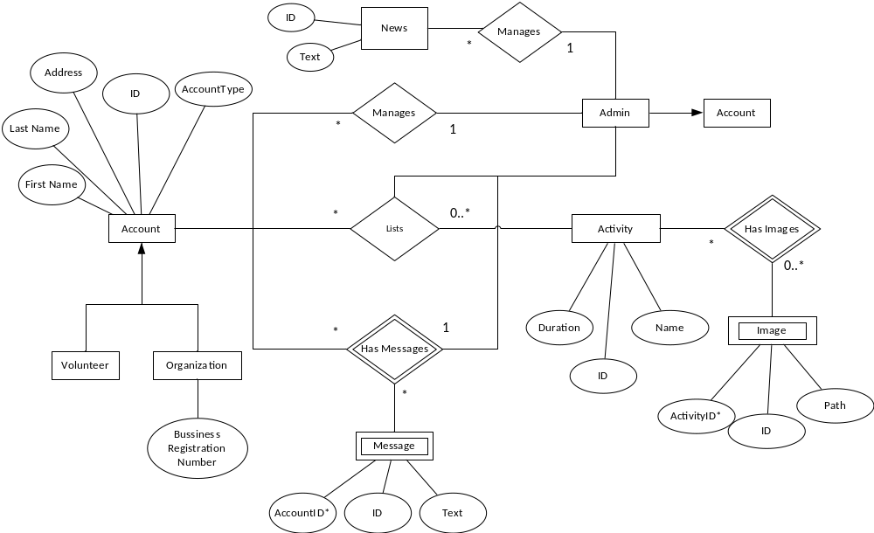
Figure 7 Logical Database View

The entity’s data type, description, and comments are listed below:
Account Data Entity
Data Item | Type | Description | Comment
First Name | Varchar | First Name of user
Last Name | Varchar | Last Name of user
Address | Varchar | Email Address
ID | Integer | Unique number as identifier. | Auto-incremental & unique
Account Type | Integer |  | Auto to 1 for user, admin must manually set it through the server.

Organization Data Entity
Data Item | Type | Description | Comment
Business Registration Number | Integer | Unique number for each registered organization with SSM

Message Data Entity
Data Item | Type | Description | Comment
ID | Integer | Unique number as identifier. | Auto-incremental & unique
AccountID | Integer | Unique number as identifier from account.
Text | Varchar | Messages from users

News Data Entity
Data Item | Type | Description | Comment
ID | Integer | Unique number as identifier. | Auto-incremental & unique
Text | Varchar | Messages from Admin to User

Activity Data Entity
Data Item | Type | Description | Comment
ID | Integer | Unique number as identifier. | Auto-incremental & unique
Name | Varchar | Internet address
Duration | Date | Article entity

Image Data Entity
Data Item | Type | Description | Comment
ID | Integer | Unique number as identifier. | Auto-incremental & unique
ActivityID | Integer | Unique number as identifier from Activity entity
Path | Varchar | Location of image stored in server

3.1.2 Security

- Users are free to view any on-going approved activity on the homepage of the website, but they can only enlist as volunteer from their profile webpage or remove the activity as Organization once they are logged into the system.

- The Admin role is to act as facilitator to ensure that Volunteers are not duped into joining any dubious activities hosted by unknown organizations. Therefor, all activities require Admin’s approval for it to show up on “Search Activity” in user’s profile webpage.
- The communication between Organization and Volunteer are not directly through the website. They communicate through personal interaction through phone calls or emails in private. The website’s message system is only for User and Admin. This is to minimalize the involvement of Admin to approving activities only and managing the content on the homepage of the website system.

- Organization’s must have a legit Business Registration Number given to them by SSM and admin should cross check the legality whenever there’s severe complains of the organization from any reliable sources. If found to be illegal, suspend the account immediately to remove all activities tied to them to be removed from user’s sight to reduce damage done.

< This is a full listing of the rest of the non-functional requirements such as performance requirements, logical database requirements, design constraints, standards compliance and software system attributes such as reliability, availability, security, maintainability and portability.
Entity-Relation Diagrams may be useful in this section or may have been used above where a careful description of the needed information structure was appropriate. >

Index

< generate here >

